**Application Form of Life Supports for University Students Living Alone**

I hereby submit the application for the KOBE EATS Project (Life Supports for University Students Living Alone).

【Applicant】

|  |  |  |  |  |
| --- | --- | --- | --- | --- |
| University |  | | Faculty/Department |  |
| Name |  | | Birthdate | |
| (YYYY/MM/DD)  / / （ Years Old） | |
| Present Address |  | | | |
| Phone Number |  | | e-mail |  |
| Food Set Delivery Address | | * Same with the Present Address (no need to fill out address in this section)   〒　　　－ | | |

【Food Set】

Please select your desired food set from A to G.

Desired Food Set 　　　　　　　　　　　　　Set

*If you do not have a food set that can be consumed only for allergies, etc., please contact Kobe City.

(Contact)

To: Kobe City Hall, Planning and Coordination Bureau, University and Education Partnerships Division

Phone：078-322-5030

Mail：student-navi@office.city.kobe.lg.jp

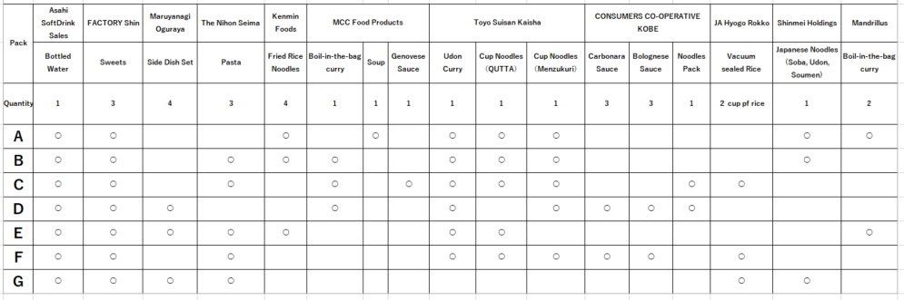

**※Make sure to confirm that the back page is filled in.**

[Written Pledge]

Please check the content and place a checkmark (☑) on the box that describes your situation. (All the following boxes must have checkmarks (☑) to be eligible for this application).

□ I am a student living or studying in the city

*A student refers to a person who is studying at a university (excluding short-term courses and advanced courses), graduate school, junior college (excluding advanced courses), technical college (only for 4th and 5th year students and advanced courses), or postsecondary course at a specialized training collage.

*In consideration of purpose of this program, people who are studying while working full time (working students, auditing students, non-degree students, etc.) are not eligible.

□ I live alone (including student dormitories and room sharing with other students).

□ I am affected by the price increases.

□ This is my first application

□ I agree that the food set and delivery address cannot be changed after submitting this application.

□ I agree that reselling the food set is prohibited.

□ I agree that the food set in principle cannot be returned nor exchanged.

□ I agree that if I apply through any malicious or fraudulent means, Kobe City may notify my school regarding my student information and will not provide the food set.

□ If I apply through any malicious or fraudulent means and have already received the food set, I agree to promptly pay the equivalent of the food set price I received upon receipt of invoice sent by Kobe City.

□ If any falsehood discovered in this written pledge, I agree that Kobe City may notify my school regarding my student information and will not provide the food set, or, if I have already received the food set, I agree to promptly pay the equivalent of the food set upon receipt of invoice sent by Kobe City.

I hereby declare that the information provided in this application is true.

(Year/Month/Date)

/ /

(Signature)

Name

※Documents that are required to put in the envelope:

- Application Form (this form).

- Copy of student ID (the side that showing name and name of university).

- (Only for students enrolled in universities outside the Kobe City) Document proving

that you live in Kobe.

[Address to send the documents]

Address: 6-5-1 Kano-cho, Chuo-ku, Kobe

To: Kobe City Hall, Planning and Coordination Bureau, University and Education Partnerships Division, KOBE EATS Project Staff Member