Municipal/Prefectural Residence Tax

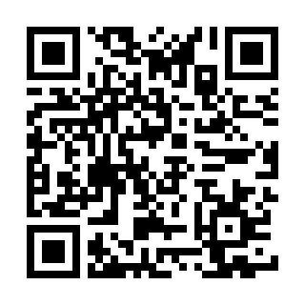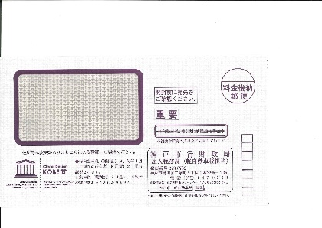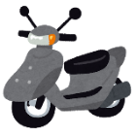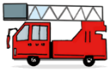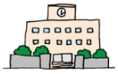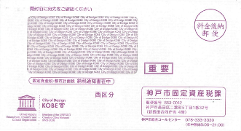

**Taxes must be paid by the due date.  
1. USING YOUR TAX INVOICE ()**

A tax invoice will be mailed to you along with your tax notice.

This tax invoice can be used at:

* banks, post offices and convenience stores
* Shin-Nagata Government Office ()

**2. DOMESTIC BANK TRANSFER**

If you set up a bank transfer, your taxes will be automatically withdrawn from your bank account in Japan.

1. **CASHLESS PAYMENTS**

You can pay these taxes on your computer, smartphone or tablet device at any time using one of the following options (Please scan the following code for details):

* Payment apps
* Credit cards
* Internet banking

All individuals who owned a motorbike, light motor vehicle (K car), small-sized special motor vehicle, or two-wheeled small motor vehicle as of April 1st must pay a Light Vehicle Tax.

We will send you a Light Vehicle Tax Notice in May.

You must pay it by May 31st.

All individuals or legal entities that owned fixed assets in the city on January 1st of each year, must pay the Fixed Property Tax/City Planning Tax.

Fixed assets include land, houses, apartments and workplace   
equipment.

We will send you a Fixed Property Tax Notice   
(・ ) in April.

All of the following individuals must pay this tax:

* Individuals who were living in Kobe as of January 1st of this year, or
* Individuals who were not living in Kobe as of January 1st, but have an office or house in the city

We will send you a Municipal Residence Tax Notice   
( ) in June.

People living and working in Japan have to pay taxes.

Tax money is used for schools, firefighting, garbage disposal, and other city services.

Fixed Property Tax/City Planning Tax

How to pay taxes

ow to

Pay

Taxes in Kobe

Light Vehicle Tax

C:\Users\208029\Desktop\t00.jpgC:\Users\208029\Desktop\g01.jpg

If you have questions about taxes in Kobe

Q & A

|  |  |
| --- | --- |
| Inquiries about Municipal Residence Tax | Municipal Residence Tax Division  TEL : (078)647-9300  FAX：(078)647-9560  E-mail address : kazeikikaku-kazei@office.city.kobe.lg.jp |
| Inquiries about Fixed Property Tax | Fixed Property Tax Division  TEL：(078)647-9400  FAX：(078)647-9429  E-mail address: koteishisanzeika@office.city.kobe.lg.jp |
| Inquiries about Light Vehicle Tax | Corporate Tax Division  TEL：(078)647-9399  FAX：(078)647-9570  E-mail address: keiji@office.city.kobe.lg.jp |
| When you are having trouble paying your taxes,  lose your tax invoice,  or don't know how to pay taxes | Tax Collection Management Division  TEL：(078)647-9530  FAX：(078)647-9591  E-mail address: [syuno-kanri@office.city.kobe.lg.jp](mailto:syuno-kanri@office.city.kobe.lg.jp) |

C:\Users\208029\Desktop\t00.jpgC:\Users\208029\Desktop\g01.jpgC:\Users\208029\Desktop\g01.jpgC:\Users\208029\Desktop\t00.jpgC:\Users\208029\Desktop\g01.jpgC:\Users\208029\Desktop\t00.jpg

Students who are receiving a salary or own a motorcycle must also pay taxes. This includes people with part-time jobs.

Before leaving Japan, please pay all taxes you were subject to while living in Japan.

Please appoint a tax representative and submit the necessary documents to Kobe City.

１. You cannot renew your visa.

２. Kobe City will forcibly withdraw the tax money from your salary and savings.

３. You will have to pay late fees.

Please inquire with the tax office that has jurisdiction over the area where you live.

Where can I ask questions about income tax?

Do students need to pay taxes?

What do I do if I’m leaving Japan (to move to another country)?

What happens if I don't pay my taxes?

**Please have someone who can speak Japanese and interpret for you when you call.**